Hotel Reservation System

System-Wide Requirements Specification v1.0

**GROUP 4**

**Irina Erofeeva**

**Durali Alagöz**

**Ömer Denizoğlu**

**M.Mert Dervişoğulları**

**Table Of Contents**

1. Introduction 2

2. System-Wide Functional Requirements 2

3. System Qualities 2

3.1 Usability 2

3.2 Reliability 2

3.3 Performance 3

3.4 Supportability 3

4. System Interfaces 3

4.1 User Interfaces 3

4.1.1 Look & Feel 4

4.1.2 Layout and Navigation Requirements 4

4.1.3 Consistency 4

4.1.4 User Personalization & Customization Requirements 5

4.2 Interfaces to External Systems or Devices 5

4.2.1 Software Interfaces 5

4.2.2 Hardware Interfaces 5

4.2.3 Communications Interfaces 5

5. Business Rules 5

5.1 User Account Rules 5

5.1.1 Two level of access should be available. 5

5.1.2 All users should be able to update their accounts. 5

5.1.3 Receptionists should be able to manage guest accounts. 5

5.2 Reservation Rules 5

5.2.1 Users should be able to perform a reservation of the room for the desired amount of days. 5

5.3 Supplementary Service Rules 5

5.3.1 User should be able to make a reservation of supplementary service, available in the hotel. 5

5.4 Cleaning Service Rules 5

5.4.1 User should be able to make a request for changing a room. 5

5.5 Payment Rules 5

5.5.1 Users should be able to perform payment operations through the Hotel Management System with cash. 5

5.5.2 Users should be able to perform payment operations through the Hotel Management System with a credit card. 5

6. System Constraints 6

7. System Compliance 6

7.1 Licensing Requirements 6

7.2 Legal, Copyright, and Other Notices 6

7.3 Applicable Standards 6

8. System Documentation 6

# Introduction

The purpose of this document is to define system-wide requirements of the Hotel Reservation System. In this tool, users will be able to perform and make reservation, manage their accounts, make payments and order other hotel facilities. This specification defines the non-functional requirements of the system such as reliability, usability, performance, and supportability as well as functional requirements that are common across a number of use cases. (The functional requirements will be defined in the Use Case Specifications.)

# System-Wide Functional Requirements

Functional requirements are captured via the defined use cases. The software product shall fulfil the functions below:

* Manage user accounts
* Manage reservations
* Manage supplementary service
* Manage cleaning service
* Manage payments

# System Qualities

This section lists all of those requirements that relate to, or affect, the usability, reliability, performance, supportability of the system.

## Usability

Ease of use; the system will not require user training beyond that of using a desktop application. This will be verified by usability tests during the beta period.

## Reliability

The System should not let any kind of data loss. In addition, system should not down more than 1 hours due to software or database related errors.

## Performance

The system shall support up to 500 simultaneous transactions against the database at any given time and up to 200 simultaneous users against the server at any one time. The system shall provide access to the database with no more than 10 seconds latency. Additionally the system must be able to complete 75% of currently active transactions within 2 minutes.

The minimum system prerequisites for the server is as follows:

* 1 GHz Processor
* 2 GB RAM
* 100MB Hard disk

For client computers, any configuration that is capable of running Java application shall be sufficient.

## Supportability

The user shall be able to utilize the system through commercially available operating systems and Java JDK/JRE 8 custom software will be required to reside on the computer.

# System Interfaces

## User Interfaces

The key user interface decisions are going to be done in next iterations. In addition, the prototype of the access interface of the Hotel Reservation System can found below:

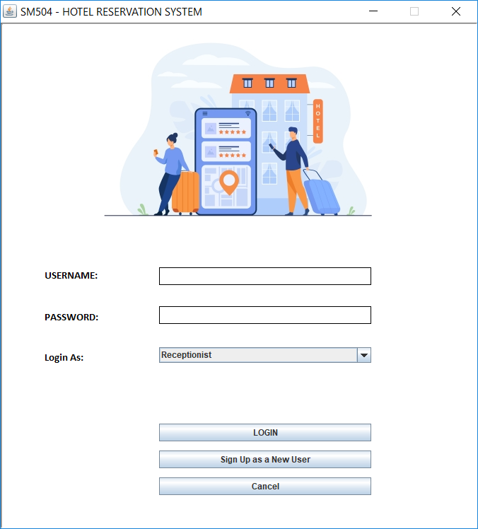

### Look & Feel

There are no specific demands of clients. Therefore the look & feel properties (style, colours, etc...) are in our discretion so we will choose this look & feel properties.

### Layout and Navigation Requirements

There are no particular demands of clients. Therefore we will decide the Layout and Navigation properties.

### Consistency

There are no particular demands of consistency. Therefore the consistency properties (Navigation controls, Screen areas sizes, shapes, etc...) are in our discretion and we will choose the templates we will use in our tool.

### User Personalization & Customization Requirements

There will be no personalization and customization in the Hotel Reservation System tool.

## Interfaces to External Systems or Devices

There are no external devices will be used the Hotel Reservation System tool.

### Software Interfaces

Java JDK 1.8_131 and MySQL interfaces will be used.

### Hardware Interfaces

No custom hardware interfaces are required.

### Communications Interfaces

The Requirements Management Tool will be connected to the Internet. Since the Hotel Reservation System is a desktop-based tool, TCP/IP protocols will be used for remote access.

# Business Rules

Business rules may evolve during the iterations.

## User Account Rules

### Two level of access should be available.

### All users should be able to update their accounts.

### Receptionists should be able to manage guest accounts.

## Reservation Rules

### Users should be able to perform a reservation of the room for the desired amount of days.

## Supplementary Service Rules

### User should be able to make a reservation of supplementary service, available in the hotel.

## Cleaning Service Rules

### User should be able to make a request for changing a room.

## Payment Rules

### Users should be able to perform payment operations through the Hotel Management System with cash.

### Users should be able to perform payment operations through the Hotel Management System with a credit card.

# System Constraints

The languages and scripts, which will be used for coding the Hotel Reservation System, are Java, Swing / AWT libraries and MySQL. For working on the construction phase of the Hotel Reservation System there is need to additional application server software such as Apache Tomcat.

# System Compliance

## Licensing Requirements

No client licenses are required.

## Legal, Copyright, and Other Notices

Copyright statements indicating content ownership shall be included in content as required by policy.

## Applicable Standards

The Unified Software Development Process (UP) guidelines for the documentation of software systems will be followed.

# System Documentation

There will be an online users-guide for the Hotel Reservation System.